Powerful PDFs
The pdf files in this folder are “powerful databases” when used as described below.

You have the papers in chronological order with the mark schemes immediately below each paper.

As shown in the image below. Download the pdf and open it with Adobe Reader (free to download). Right click anywhere on the open file. Select “find”. On the ‘find box’, click on the down arrow to the right of the window to enter the search term. Select the option “open full reader”. Then do your search. In just a few seconds it will find all occurrences of that word or term. That way you can test yourself selectively on any subtopic.

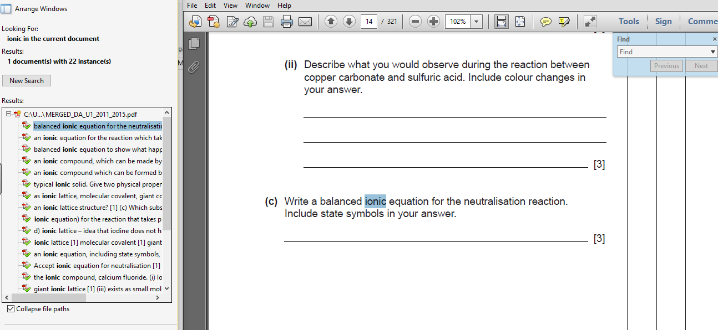

From www.franklychemistry.co.uk
Helping to making learning easier.

